TYPE THE TITLE OF YOUR PAPER HERE Without dot at the end. Titles should be brief AND informative.

First Author (full name, EG: KARTINI KRAMADIBRATA)
Affiliation institution, address, City, Country. E-mail:
The names and email addresses entered in this journal site will be used exclusively for the stated purposes of this journal and will not be made available for any other purpose or to any other party.
Eg. Centre for Plant Conservation, Bogor Botanic Gardens, LIPI, Jln. Ir. H. Juanda No. 13 Bogor, 1612, Indonesia. E-mail: abc@lipi.go.id

SECOND Author (full name, EG. JAN FRITS VELDKAMP)
Affiliation institution, address, City, Country. E-mail:

THIRD Author (full name, EG. Mark fleming newman)
Affiliation institution, address, City, Country. E-mail:

Abstract
FIRST AUTHOR SURNAME, FIRST AUTHOR MIDDLE and or SECOND NAME INITIAL (EG. KRAMADIBRATA, K.), SECOND AUTHOR SURNAME, SECOND AUTHOR MIDDLE and or SECOND NAME INITIAL (EG. VELDKAMP, J. F.) & THIRD AUTHOR SURNAME, THIRD AUTHOR MIDDLE and or SECOND NAME INITIAL (EG. MARK, F. N.). Year of publication. Type the title of your paper here. Reinwardtia Volume(No): . — Write your abstract here. Abstract is not more than 250 words. The abstract should be concise and factual. State briefly the purpose of the research, material and method, the principal results and major conclusions. An abstract is often presented separately from the article, so it must be able to stand alone. For this reason, References should be avoided. Also, non-standard or uncommon abbreviations should be avoided, but if essential they must be defined at their first mention in the abstract itself.

Key words: keywords contain three to five words/phrases separated with coma. The keywords should be avoiding general and plural terms and multiple concepts. Be sparing with abbreviations: only abbreviations firmly established in the field may be eligible. These keywords will be used for indexing purposes.

AbstraK
FIRST AUTHOR SURNAME, FIRST AUTHOR MIDDLE and or SECOND NAME INITIAL (EG. KRAMADIBRATA, K.), SECOND AUTHOR SURNAME, SECOND AUTHOR MIDDLE and or SECOND NAME INITIAL (EG. VELDKAMP, J. F.) & THIRD AUTHOR SURNAME, THIRD AUTHOR MIDDLE and or SECOND NAME INITIAL (EG. MARK, F. N.). Year of publication. Type the title of your paper here in Bahasa Indonesia. Reinwardtia Volume(No): . — Write your abstract here in Bahasa Indonesia.

Kata kunci: type keywords here in Bahasa Indonesia.

INTRODUCTION

This guideline is a template for writing the manuscript for Reinwardtia submission and this guideline is available online at Author Guidelines page on Reinwardtia official website at http://e-journal.biologi.lipi.go.id/index.php/
reinwardtia/about/submissions#author Guidelines. Authors are allowed to modify this template for submission purpose.
Manuscript is original paper and represent an article which has not been published in any other journal or proceedings. The manuscript of no more than 30 pages uses Times New Roman, MS Word for Windows of A4. New paragraph should be indented in by 4 characters. The text is single-spaced; uses a 11-point font; employs italics, rather than underlining (except with URL addresses); and all illustrations, figures, and tables are placed within the text at the appropriate points, rather than at the end.
In the Introduction, state the objectives of the work and provide an adequate background, avoiding a detailed literature survey or a summary of the results. Explain how you addressed the problem and clearly state the aims of your study.

MATERIALS AND METHODS

State the objectives of the work and provide an adequate background, avoiding a detailed literature survey or a summary of the results. A Theory section should extend, not repeat, the background to the article already dealt with in the Introduction and lays the foundation for further work.

TAXONOMY

When there is Taxonomic identification key, the key should be prepared using the aligned couplet type. Nomenclature should strict adherence to the International Code of Botanical Nomenclature, so that taxonomic and nomenclatural novelties should be clearly shown. English description for new taxon proposed should be provided and the herbaria where the type specimens area deposited should be presented. Name of taxon in taxonomic treatment should be presented in the long form that is name of taxon, author's name, year of publication, abbreviated journal or book title, volume, number and page.

Identification key to certain species
Eg.
1a. Plants ………………………………..........2
1b. Plants ……………………………………...3
2a. Flowers …………………………..Species a
2b. Flowers …………………………...Species b

SPECIES DECRIPTIONS
(for new species, see below)

1. Genus species Author, spec. nov. Fig. x. — Type: Country, Province, Regency, habitat, latitude, longitude, date, Collector & Collector No. (holotype: XX, isotype: YY).

(for latitude and longitude please use the format as follow: 0º27’55.6’’N, 127º44’42.3’’E)
(for date please use the format as follow 14 May 2013)

(for non new species, see below)
1. Genus species Author, year of publication, abbreviated journal or book title, volume, number and page.
— Type: Fig. 1.

Map, line drawing illustration, photograph or plate preferably should be prepared in landscape presentation to occupy two columns. Illustration must be submitted as original art accompanying, but separated from the manuscript. The illustration should be saved in JPG or GIF format at least 350 pixels. Legends or illustration must be submitted separately at the end of the manuscript.

Diagnosis. Write the diagnostic characters of the species/new species here.

Description. Write the description of the species/new species here. Use symbol “×” to describe dimension (eg. lateral lobes 2.4−2.7 × 0.7−1.0 cm), symbol “−“ to describe range (eg.
Peduncle 2−2.5 cm long), ”ca.” to describe around (eg. Rhizome ca. 10 mm diameter).

Distribution. Write the distribution of the species/new species here.

Etymology. Write the etymology of the species/new species here.

Phenology. Write the phenology of the species/new species here (if applied).

Conservation status. Write the conservation status of the species/new species here (if applied)

Notes. Write the notes of the species/new species here.

Specimens examined. Please follow the format: Collector coll.no. (herbarium code), Country, Province, Regency, latitude, longitude, altitude, date, phenology or habitat data.

Eg. M. Ardiyani, Ari Anggara & Pitra Akhriadi 189 (ANDA, BO, E), Indonesia, West Sumatra, Kabupaten Agam, Kecamatan Tanjung Raya, Kanagarian Koto Malintang, Maninjau, Labuah Baru, 0º27’55.6’’N, 127º44’42.3’’E, 1210 ft, 8 July 2009, flowering and fruiting; M. Hotta & T. Kohyama 356 (ANDA), Western Maninjau, Muko-muko, small hill behind Field Research Station of Andalas University, 500 m, 11 Sept. 1984.

Figure should be in grayscale, and if it made in color, it should be readable when it later printed in grayscale. Caption should be numbered, in 10 TNR and single spaced. A caption should comprise a brief title (not on the figure itself) and a description of the illustration. Keep text in the illustrations themselves to a minimum but explain all symbols and abbreviations used. The lettering on the artwork should be clearly readable and in a proportional measure and should have a finished, printed size of 7 pt for normal text and no smaller than 6 pt for subscript and superscript characters. Figures should have a brief description in the main body of text.
For layouting purpose, please provide the respective high resolution figure (≥300dpi) separately in.tif/.jpg/.jpeg within a particular folder apart from the manuscript. Moreover, kindly avoid mentioning position of figure/table e.g. “figure below” or “table as follow” because the position will be rearranged in layouting process. DO NOT put boxes around your figures to enclose them.

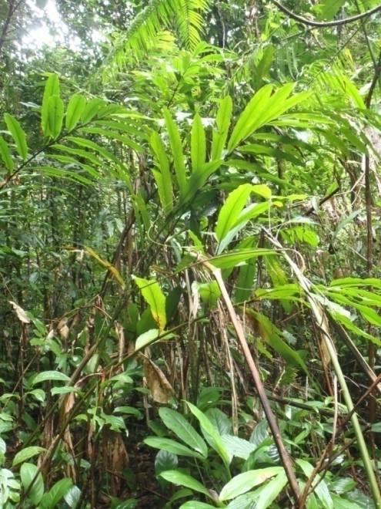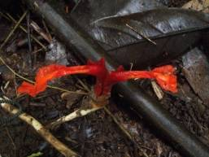
A
B

Fig. 1. Figure Caption in 10 pt TNR (align text left with dot at the end of the sentence). A. Notes; B. Notes. (Photos: Name/names).

If there is a table, number of table consecutively in accordance with their appearance in the text. Avoid vertical rules. Be sparing in the use of tables and ensure that the data presented in tables do not duplicate results described elsewhere in the article

Tabel 1. Table Caption in 10 pt TNR (align text left without dot at the end of the sentence)

Species | Character
a | D
b | E
c | F

Acknowledgments
Write the acknowledgment here in 10 pt TNR.

References
Bibliography, list of literature cited or references follow the Harvard system as the following examples in 10 pt TNR.
KRAENZLIN, F. 1913. Cyrtandraceae novae Philippinenses I. Philipp. J. Sci. 8: 163-179.
MAYER, V, MOLLER, M, PERRET, M. & WEBER, A. 2003. Phylogenetic position and generic differentiation of Epithemateae (Gesneriaceae) inferred from plastid DNA sequence data. American J. Bot. 90: 321-329.
TEMU, S. T. 1995. Peranan tumbuhan dan ternak dalam upacara adat "Djoka Dju" pada suku Lio, Ende, Flores, Nusa Tenggara Timur. In: NASUTION, E. (Ed.). Prosiding Seminar dan Lokakarya Nasional Etnobotani II. LIPI & Perpustakaan Nasional: 263-268. (In Indonesian).
SIMBOLON, H. & MIRMANTO, E. 2000. Checklist of plant species in the peat swamp forests of Central Kalimantan, Indonesia. In: IWAKUMA et al. (Eds.) Proceedings of the International Symposium on: Tropical Peatlands. Pp,179-190.
RIDLEY, H. N. 1923. Flora of the Malay Peninsula 2. L. Reeve & Co. Ltd, London. Part of Book: BENTHAM, G. 1876. Gesneriaceae. In: BENTHAM, G. & HOOKER, J. D. Genera plantarum 2. Lovell Reeve & Co., London. Pp. 990-1025.
BAIRD, L. 2002. A Grammar of Keo: An Austronesian language of East Nusantara. Australian National University, Canberra. [PhD. Thesis].
http://www.nationaalherbarium.n1/ftncollectors/k/KostermansAJGH.htm). Accessed 15 February 2012.

